**CSA1072 Software Engineering**

**NAME: Cherukuri sai murali**

**Reg number: 192211951**

EXPERIMENT NUMBER 1: E-wallet is an online prepaid account where one can stock money, to be used when required. As it is a pre-loaded facility, consumers can buy a range of products from airline tickets to grocery without swiping a debit or credit card. You are required to design a similar EWallet Management System (EMS) using Use case diagram

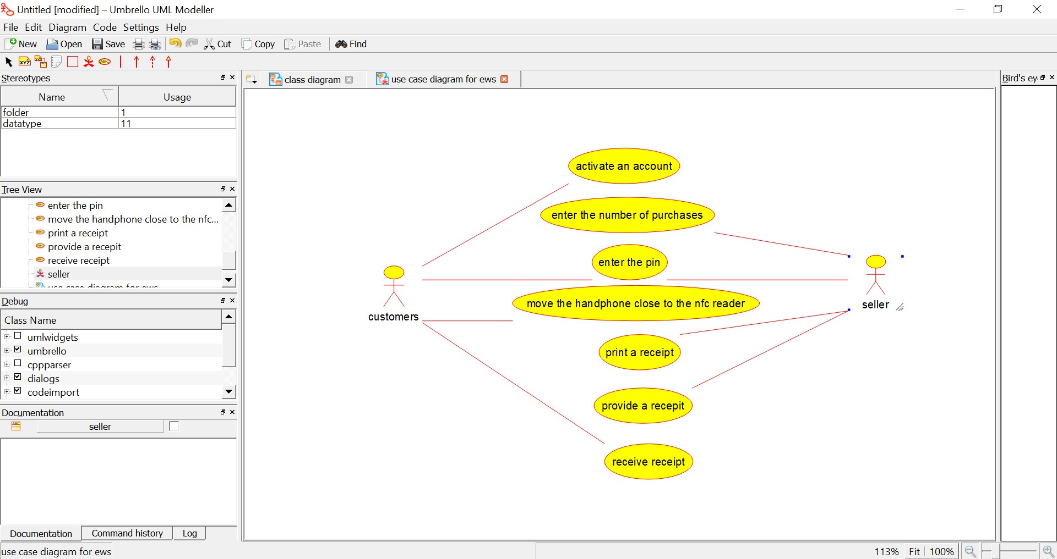

EXPERIMENT NUMBER 2: Make a class diagram to model for a quiz system. A user can request a quiz for the system. The system picks a set of questions from its database, and composes them together to make a quiz. It rates the user’s answers and gives hints if the user requests it. In addition to users, we also have helpers who provide questions and hints. And also administrators who must certify questions to make sure they are not too trivial and those they are correct.

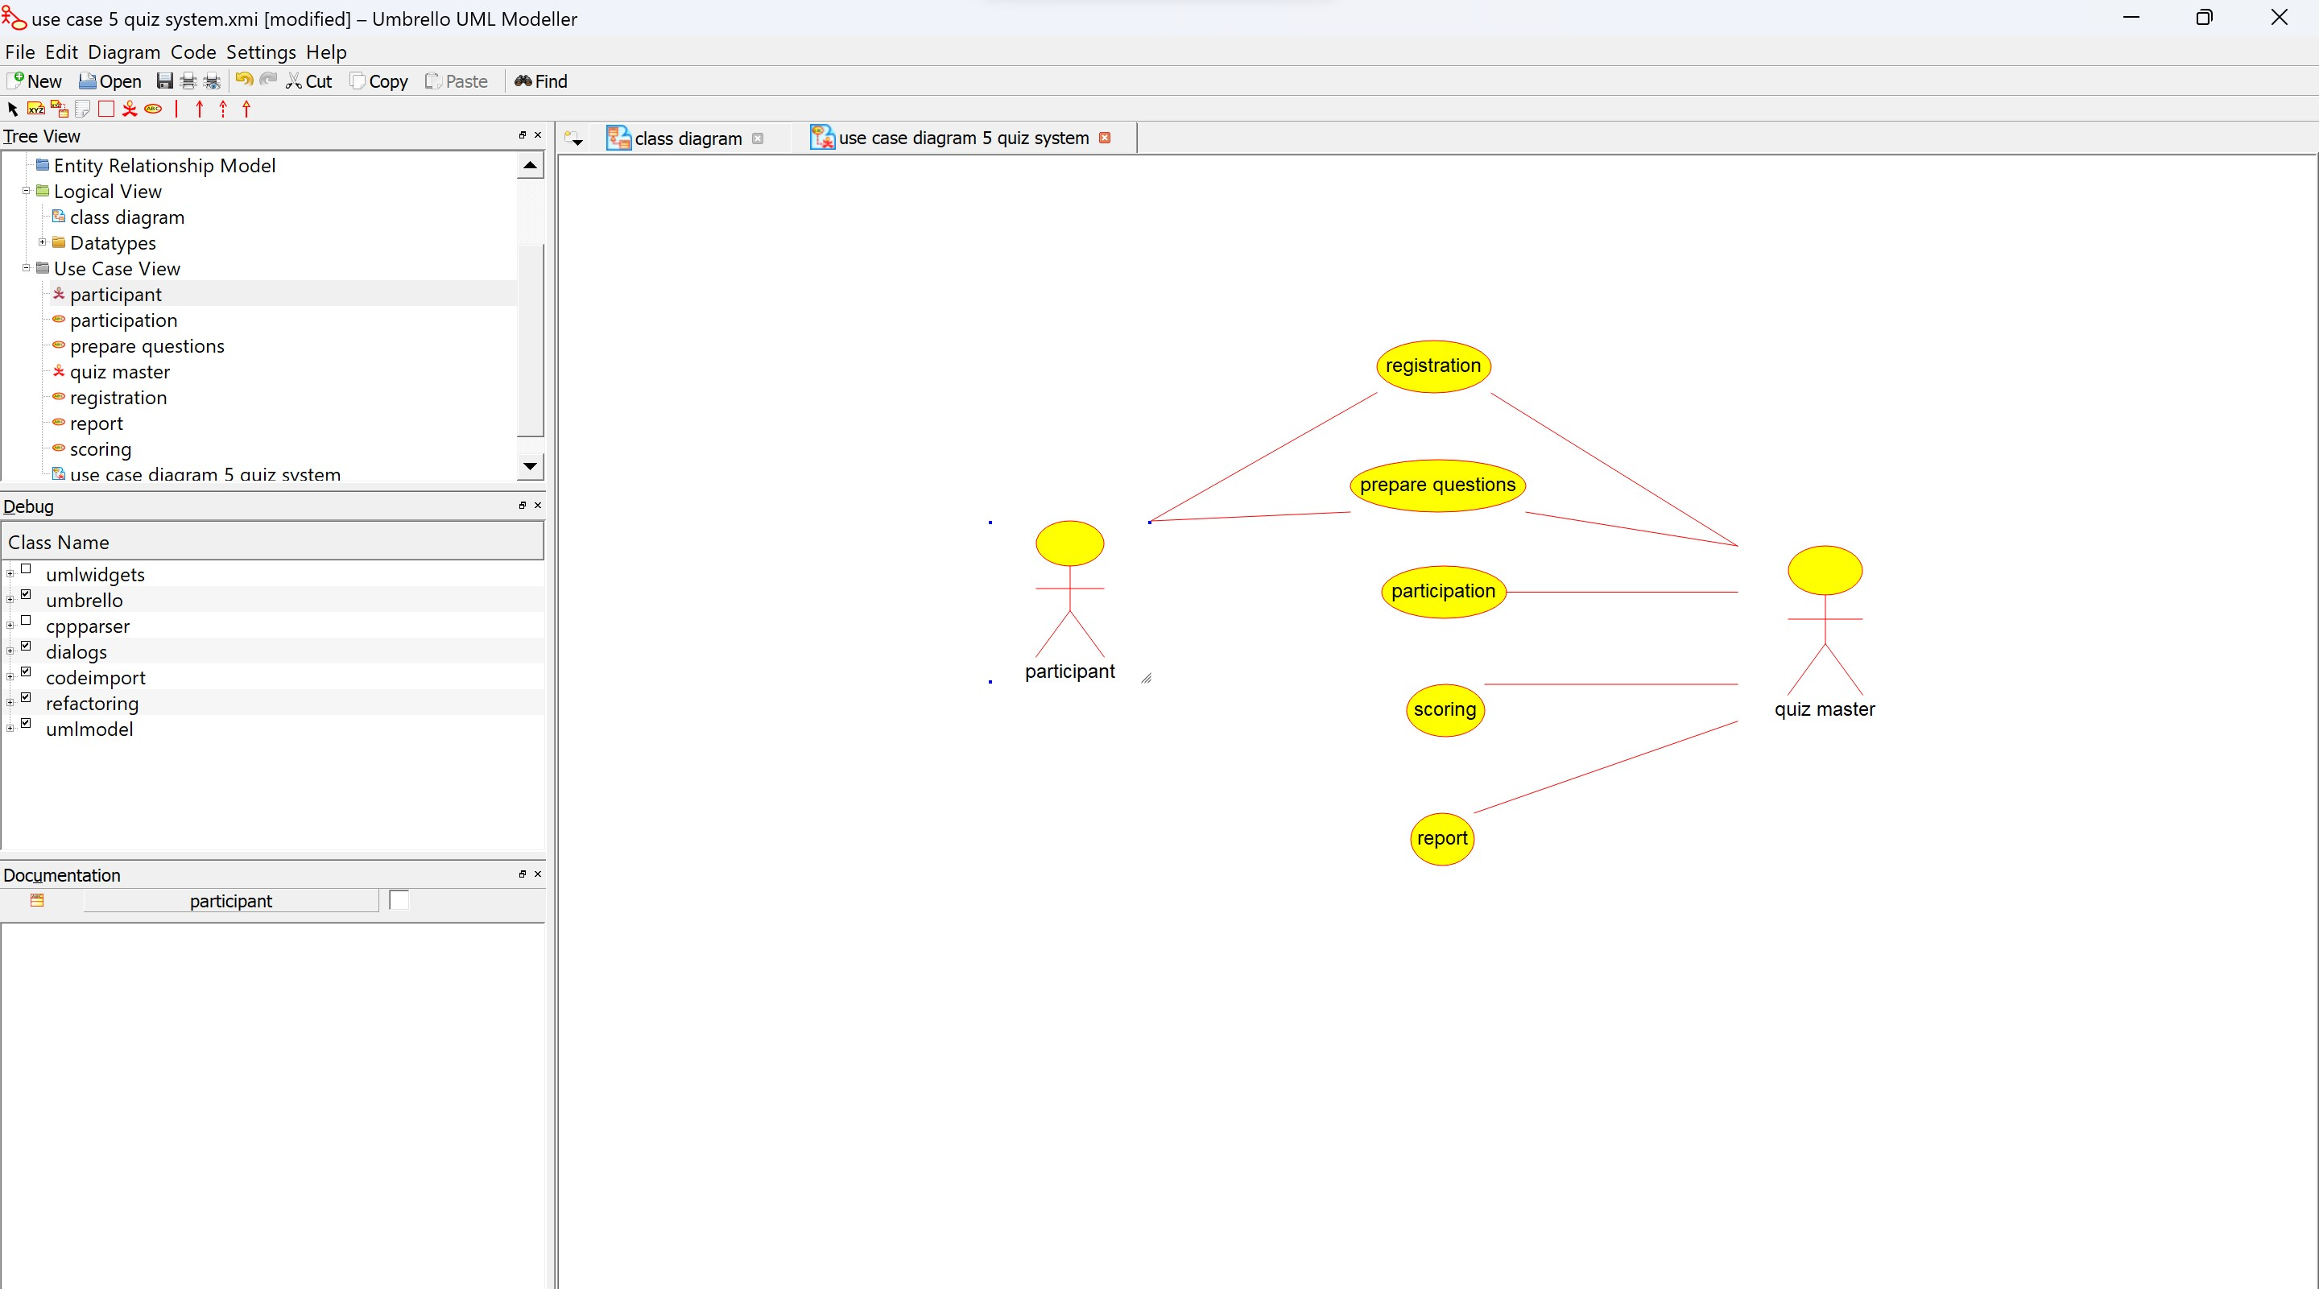

EXPERIMENT NUMBER 3: